# ECO Bios and Profile Photos

**Dr. Bruno Artacho (Amazon Easy Check-Out Science)** is an Applied Scientist in the Easy Check-Out (ECO) Science team at Amazon working on the research and development of Computer Vision applications for Dash Carts and cashier-less applications including object tracking, quantity estimation, and synthetic data generation. He received his Ph.D. in Electrical and Computer Engineering focusing on Human Pose Estimation and Segmentation from the Rochester Institute of Technology in Rochester, NY. He also worked at Google optimizing face and person detections for several products and services, and Transport Canada collaborating for the first framework to assess risk and build Canadian Airspace and Unmanned Systems Regulation.

Email: [baartach@amazon.com](mailto:baartach@amazon.com)

Website: <https://www.amazon.science/author/bruno-artacho>



**Dr. Austen Groener (Amazon Easy Check-Out Science)**is an Applied Scientist on the Easy Check-Out (ECO) Science team at Amazon AWS working on researching and deploying Computer Vision and AI applications at-scale for the Amazon Dash Cart and similar retail innovations. His research interests primarily focus around developing solutions for real-time product identification (PI) and shopper activity recognition. Previously, he worked as a Research Scientist at Lockheed Martin Space where he worked in object detection and anomaly detection for RADAR and electro-optical remote sensing platforms. He received is Ph.D in Physics from Drexel University in Philadelphia, PA.

Email: [austengr@amazon.com](mailto:austengr@amazon.com)

Website: <https://www.amazon.science/author/austen-groener>



**Dr. Yin Wang (Amazon Easy Check-Out Science)** is an Applied Scientist of the Easy Check-Out (ECO) Science team at Amazon working on Computer Vision and Machine Learning Applications in the AI driven smart shopping cart. His research interest focuses on visual event understanding. Previously, he worked as a Research Scientist at Motorola Solutions, where he led a team on Computer Vision in surveillance, such as object detection, person re-identification and scene understanding. Before that, he was a research intern at the Computer Vision team in Mitsubishi Electric Research Laboratories (MERL). He received his Ph.D degree in Electrical and Computer Engineering from Northeastern University in Boston, MA.

Email: [xwangyin@amazon.com](mailto:xwangyin@amazon.com)

Website: <https://www.amazon.science/author/yin-wang>

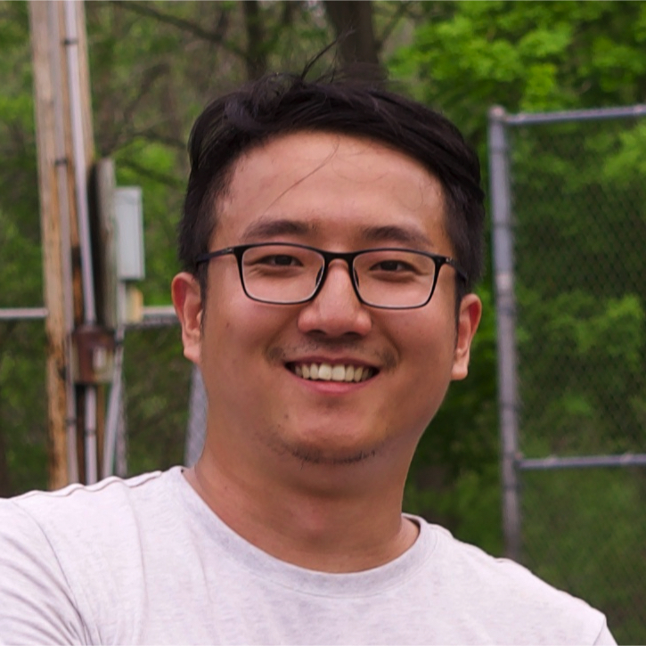

**Dr. Weijian Li (Amazon Just Walk Out Science)** is an Applied Scientist at the Just Walk Out (JWO) Science team at Amazon AWS working on research and development of Computer Vision applications. Before joining JWO, he was with the Easy Check-Out (ECO) Science team. He received his Ph.D. in Computer Science at the University of Rochester, NY. His recent research focuses on multimodal learning for video and scene understanding.

Email: [weijianl@amazon.com](mailto:weijianl@amazon.com)

Website: <https://www.amazon.science/author/weijian-li>



**Dr. Sean Ma (Amazon Easy Check-Out Science)** is currently senior applied science manager and head of research in Amazon Easy Check-Out (ECO) Science team. His team developed Amazon Dash Cart, a fully automatic shopping cart that help customers to save money and time. Before that, he was Research Manager II at HERE Technologies, where he spent 7 years working on computer vision research for mapping, and had extensive experience on outdoor mapping for autonomous driving, especially high-definition map creation, highly automated driving (SAE Level 3-5), autonomous auto-taxis, highway pilots, localization, perception. He was recipient of the 2018 Highly Automated Driving (HAD) Achievement Award from HERE Technologies, in recognition for his contribution to the highly automated driving and high-definition map automation using computer vision and AI. He was recipient of the 2013 and 2014 Nokia Global Hackathon top awards and holds 15+ US and EU patents. He was the co-organizer of 2022 Amazon Computer Vision Conferences (ACVC), and the organizer of 2019, 2020 and 2021 CVPR Tutorials - Vision Meets Mapping - Computer Vision for location-based reasoning and mapping, and invited speakers at Boston CV Meetup in 2023, AIAI Computer Vision Summit in 2022, and Chicago ML meetups in 2018-2019. Dr. Ma received Ph.D. and M.S. in Electrical and Computer Engineering from the University of Illinois Chicago.

Email: [seanman@amazon.com](mailto:seanman@amazon.com)

Website: <https://www.amazon.science/author/sean-ma>



**Dr. Sharmin Rahman (Amazon Easy Check-Out Science)** is a Research Scientist on the Easy Check-Out (ECO) Science team at Amazon working on Robotics and Computer Vision applications for the Amazon Dash Cart. Her research interests include real-time localization and mapping fusing low-cost sensors in challenging environments. Previously, she worked as a Computer Vision Scientist at [Alarm.com](http://Alarm.com) where she worked on visual-inertial odometry for home security drones. She was also an intern at Oculus AR/VR, Meta working on mapping and improving the optimization pipeline. She received her Ph.D in Computer Science and Engineering from University of South Carolina in Columbia, SC.

Email: [rahmansn@amazon.com](mailto:rahmansn@amazon.com)

Website: <https://www.amazon.science/author/sharmin-rahman>



**Ananth Sadanand (Amazon Science, Easy-Checkout, Self-Checkout)** is a Sr. Applied Scientist working on computer vision and sensor processing pipelines for the Dashcart and Self-Checkout retail divisions at Amazon. Ananths recent work includes building vision and weight scale components that power the 1st and 2nd generation of Dashcarts as well as enabling a friction free checkout experience at Self-Checkout stations in grocery stores. His interests lie in developing state-of-the-art technology and bringing them into the hands of the end consumer. Previously, Ananth worked on building the vision pipeline for video surveillance analytics at Motorola solutions and real-time NFL football analytics for DirecTV. Ananth received his Masters in Computer Science from SUNY, Buffalo in 2012 and currently resides in the Greater Boston Region.

Email: [ananthsr@amazon.com](mailto:ananthsr@amazon.com)

Website:<https://www.amazon.science/author/ananth-sadanand>



**Mohsen Malmir** (**Amazon Easy-Checkout**) is an Applied Scientist working on computer vision solutions for the Amazon Dash Cart platform. Currently, he is working on the verification of products purchased using Amazon smart shopping carts. Mohsen’s previous work and research interests include authentication and verification using machine learning, reinforcement learning and social robotics. Previous to Amazon ECO, Mohsen has worked in Amazon Alexa, Amazon Robotics AI, Soroco and Mitek Systems.  He received his PhD in computer science from University of California, San Diego.

Email: [malmim@amazon.com](mailto:malmim@amazon.com)

Website: <https://www.amazon.science/author/mohsen-malmir>